**How to create a CLONE**

Step-1: open GitHub Repository

1. Go to GitHub repository you want to clone
2. 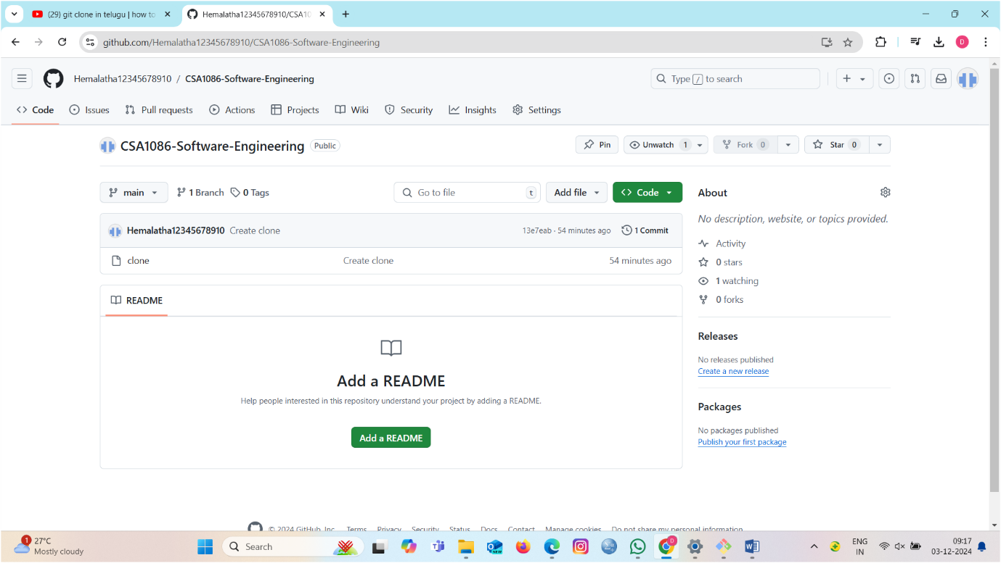

**Step-2: We have to find the Clone Button**

1. On the repository page, find the "Code" button on the right side (above the file list).

**Step-3: Copy the Clone URL**

1. After clicking the "Code" button, you'll see the clone options.
2. You can clone using HTTPS, SSH, or GitHub CLI.
3. For now, copy the HTTPS URL (it will look like <https://github.com/username/repository.git>).
4. Click the copy button next to the URL:

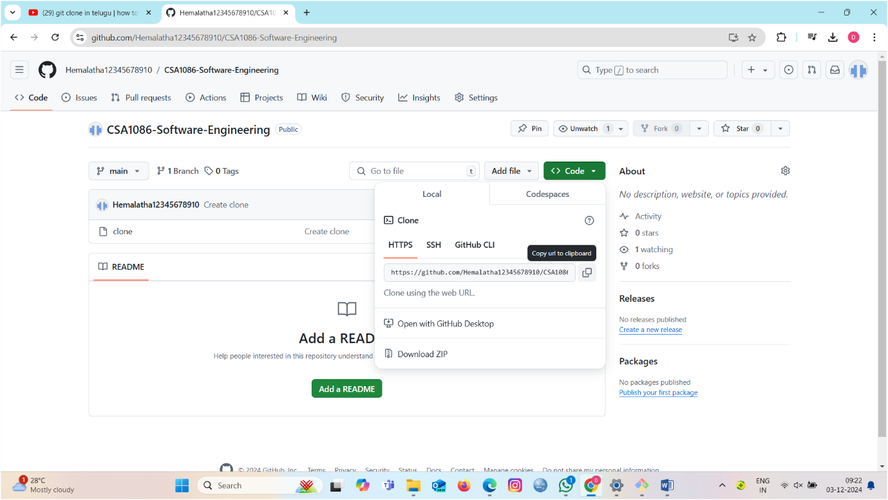

**Step-4: Open your files**

1. Now we create a new folder name sample and we select the name and copy and paste on Gitbash.

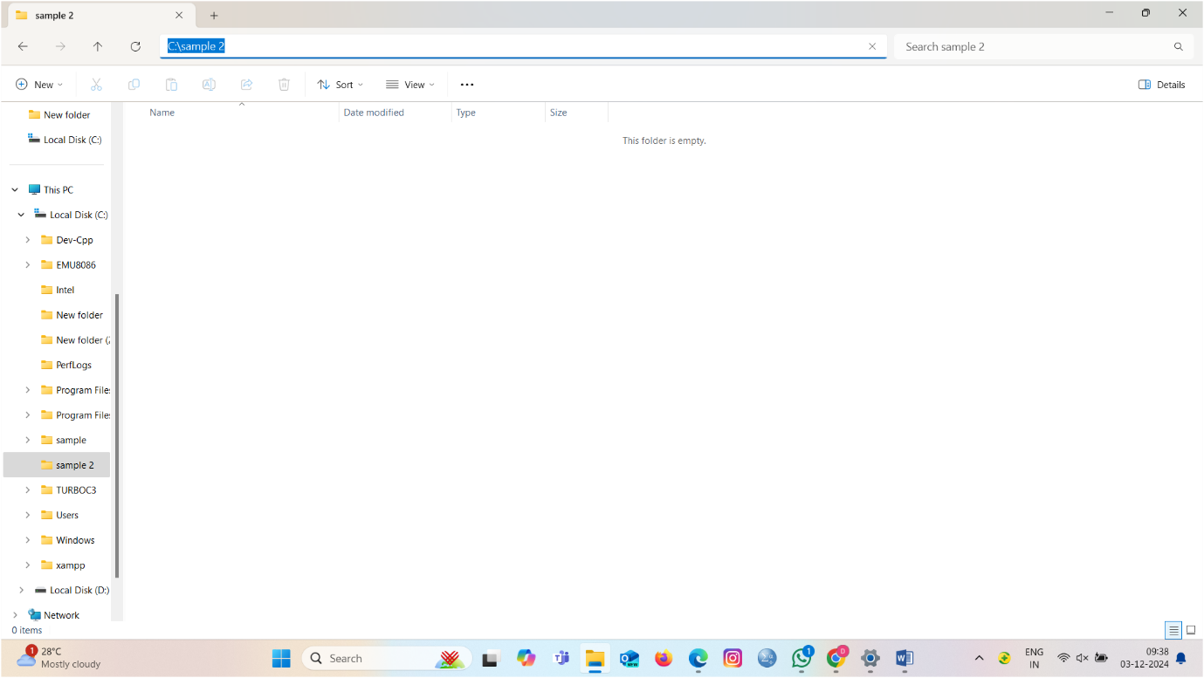

**Step-5: Run the Clone Command**

1. In your folder, type the following command:
2. git clone https://github.com/Hemalatha12345678910/CSA1086-Software-Engineering.git
3. Replace https://github.com/Hemalatha12345678910/CSA1086-Software-Engineering.git with the URL you copied earlier.

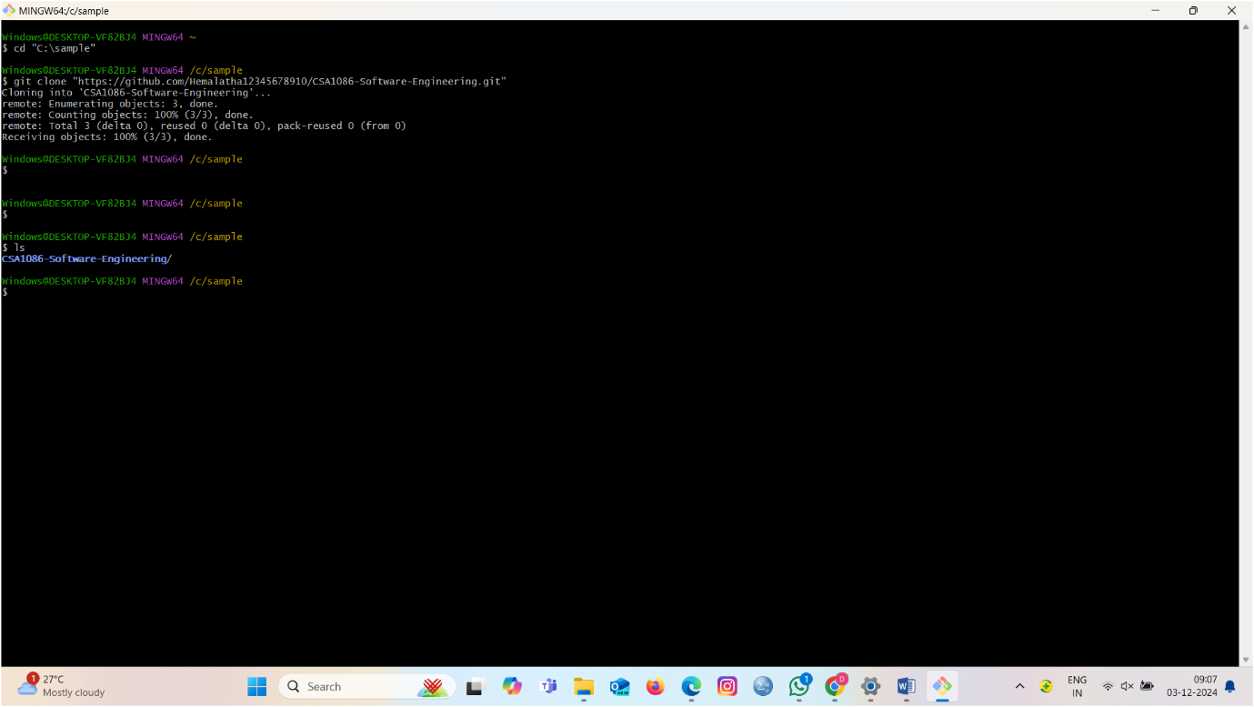

**Step-6: Press Enter**

1. Press Enter after typing the command. Git will now clone the repository to your local machine.
2. You will see output like this:
3. Cloning into ‘’CSA1086-Software-Engineering’’….
4. Remote: Enumerating objects:3. Done.
5. Remote: counting objects:100(3/3). Done.
6. Remote:Total 3 (delta 0). Revsed 0 (delta 0). Pack-revsed 0(from 0)
7. Receiving objects: 100% (3/3). Done.

Step-7: Navigate into the Cloned Repository

1.After cloning, you need to navigate into the repository directory:

2. Replace repository with the actual name of the repository.

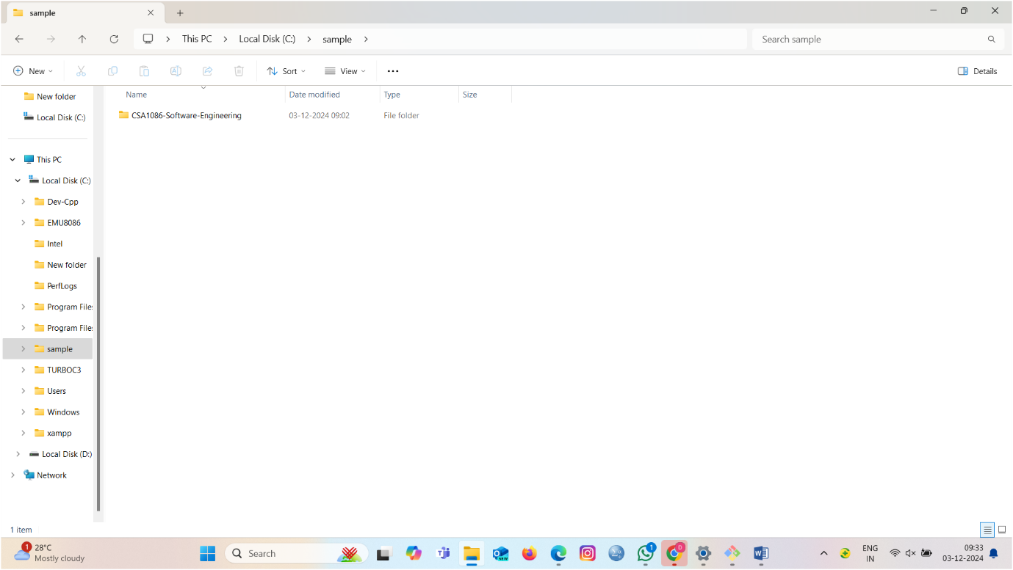

**Step-7: . Check the Repository Files**

1. List the files in the repository with:
2. Ls
3. You should see the files from the repository on your local machine.